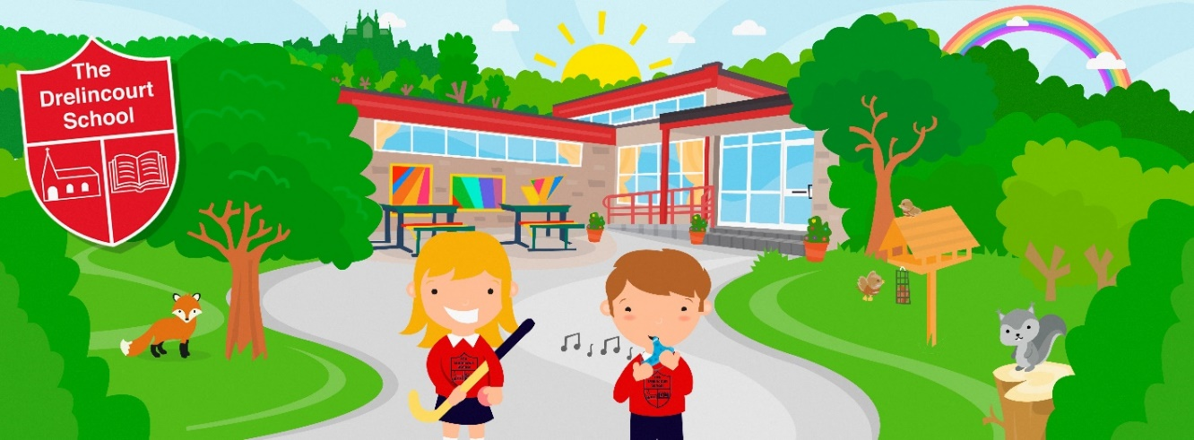

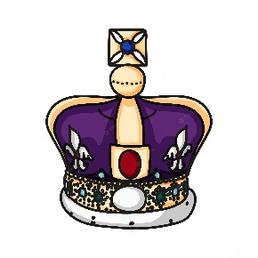
NEWSLETTER
April/May 2023

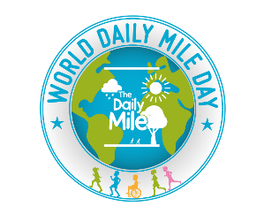
World Daily Mile is on Thursday 27th April and we will be joining with children all around the world to do our daily mile. Look our for photos on our website.

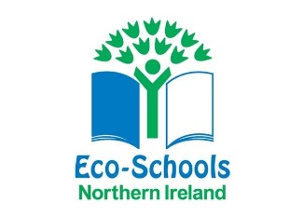
In May our ECO School’s focus is on litter and we will be looking at all the things we can do in school and to help our world. We will be participating in the BIG Spring Clean by collecting litter in our local Folly Glen

Swimming for all children will start on Monday 15th May. Please make sure your child has their swimming bag and a coat.

We will be participating in Beep Beep Day and learning about how to stay safe on the roads.

School will be closed on Monday 1st May for the bank holiday.

We will be celebrating the King’s coronation on Friday 5th May. We will have a tea party with the children so no need to send snack in as all will be provided. The children will also receive gifts to mark this wonderful occasion. School will finish at 12 noon and there will be no school lunch.

SCHOOL WILL ALSO BE CLOSED ON MONDAY 8th MAY FOR THE BANK HOLIDAY

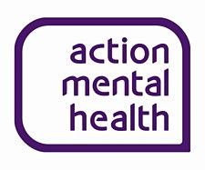
Monday 15th to Friday 19th is Mental Health Awareness Week and we want everyone to dress in purple on Friday 19th and we will be thinking about looking after our mental and emotional health.

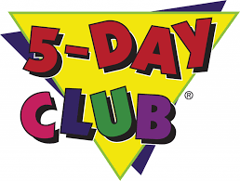
Tuesday 23rd – Friday 26th May CEF will be coming to school to do a special Bible Week Club.

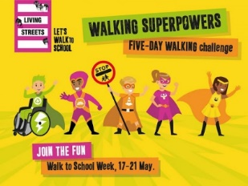

Monday 15th – Friday 19th May is Walk to School Week and we will be looking at how we get to school and trying to walk more.

Thursday 19th May is Outdoor Classroom Day, and we will have lots of outdoor learning activities in our amazing school grounds.

SCHOOL WILL BE CLOSED ON MONDAY 29th MAY FOR THE BANK HOLIDAY AND TUESDAY 30th MAY FOR STAFF TRAINING.

Wednesday 31st May is National Biscuit Day. We will be decorating and making biscuits.

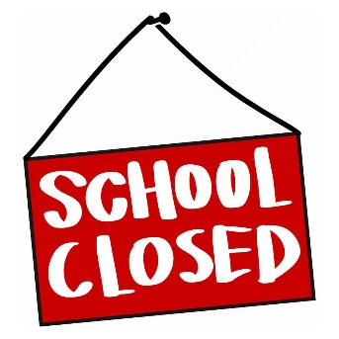
School will be closed
- Monday 1st May – Early May Bank Holiday
- Monday 8th May – Coronation Bank Holiday
- Monday 29th May – Spring Bank Holiday
- Tuesday 30th May – Staff Training Day
- SCHOOL CLOSES AT 12 NOON ON FRIDAY 5th MAY

