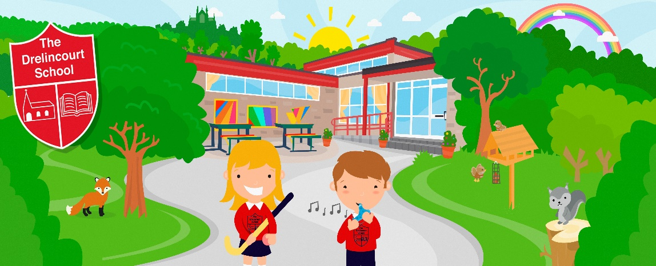

Dear Parent
As a school community we want to support Ukraine. This week we are holding an urgent collection for Ukrainian refugees.
We will be supporting Colin Tinsley from ‘Hope for Youth Ministries’ for items to go out from Northern Ireland to Poland. Colin has been in our school to take assemblies, his wife is Polish and they are both currently in Poland assisting Ukrainian refugees crossing the border.
If you would like to kindly donate, please see the list of items below:
- Toothbushes
- Toothpaste
- Soap
- Face Cloths
- Shower Gels
- Towels
- Single bed fitted sheets
- Pillows
- Pillow cases
- Blankets
- Shoes
- Clothes for any age group
- Coats
- Gloves/Scarves
- Sanitary Products
Please do not send in old clothes that you would not use. Please donate products that are new or like new.
We understand that you may have already made donations elsewhere but if you wish to take part in our appeal, please bring your items to school on or before Friday 4th March.
Thank you so much for your support

