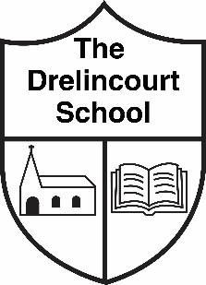

NEWSLETTER UPDATE
October 2020

** SCHOOL CLOSED MONDAY 19th OCTOBER – FRIDAY 30th OCTOBER
SCHOOL RE-OPENS MONDAY 2nd NOVEMBER*

Yesterday the Northern Ireland Executive announced that schools will have the half term break extended from 19th October to 30th October. Schools will be closed for all pupils during these two weeks.

School will re-open on Monday 2nd November.
How we stay in touch with you

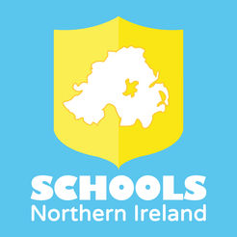
Website - Please download the app (free) to enable you to receive messages. The content can also be translated into different languages which we hope will be helpful.

We also have a text message system to your mobile phone number.

We also put information, news and updates on the school website. Please check regularly.
www.drelincourt.org.uk

We also use email and you can email us at
info@thedrelincourt.armagh.ni.sch.uk

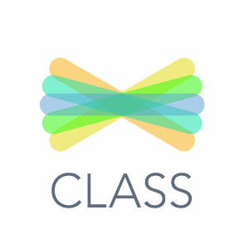
We have sent home information with all children about how to log on to Seesaw.
This is an online platform that the children have been using in school and which we will be using for homework after the half-term break. It will also be very useful if there is a need in the future to return to remote learning. Please log on and get your child to do the first activity so we know the system is up and running.

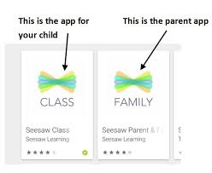
Seesaw also has a family app which parents download to their phone and this is a communication tool which translates messages from school into the home language on the phone. We think this will be very helpful and we will send parents a text message/email with the link to download.

Covid 19 remains a very considerable issue in society and we continue to follow all guidance from the Department of Education.

Any parents wishing to place orders for photographs please send in tomorrow as we will be sending the orders then. You can also order online at www.csmoments.co.uk

** SCHOOL CLOSED MONDAY 19th OCTOBER – FRIDAY 30th OCTOBER
SCHOOL RE-OPENS MONDAY 2nd NOVEMBER*

