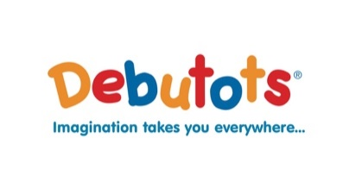

Dear Parent,

I hope you are all well. I am writing from Debutots Mid Ulster. Debutots is a drama in education company.

The Drelincourt School, Armagh has covered the cost of our exciting online classes which will entertain your children as they develop their language skills and ignite their imaginations. Our extensive follow up activity packs will help you and your little one to continue the theme together at home. The story that we are providing on behalf of The Drelincourt School is:

Fazzi’s First Day at Big School

Join Fazzi as she meets new friends, understands new rules and learns new and exciting things at Big School! This delightful story will leave your little ones excited to follow in Fazzi’s footsteps as they prepare to embark on their Big School life and make new friends.

Our fabulous class is complete with music, dancing, bubbles, puppets and more! Combined with a jam-packed activity pack and certificate to share afterwards, our workshop is the perfect step to support your child's transition to school.

To access these sessions at no cost to you, please complete the following form:

https://forms.gle/cot9Yko6bxrTE3hU9

The video will be available from 1st July 2020, you will have access to this story until the end of August

Once the Google Form has been populated and the date to air your class has arrived, I will email the passworded link to the Vimeo Video ONLY to those who have completed the google form, together with the activity pack and certificate.

I hope that you and your child enjoy watching Fazzi’s First Day at Big School.

Kind Regards
Sarah Luckman
Debutots Franchisee
Mid Ulster ( including Armagh, Banbridge, Craigavon, Cookstown and Dungannon)

A Debutots Early Years Drama franchise owned and operated under licence by
Sarah Luckman BA(Hons)QTS, M.Ed in Creative Arts, Adv.Cert.Pd, PQH(NI)

sarah.luckman@debutots.co.uk Facebook: Debutots Mid Ulster www.debutots.co.uk

