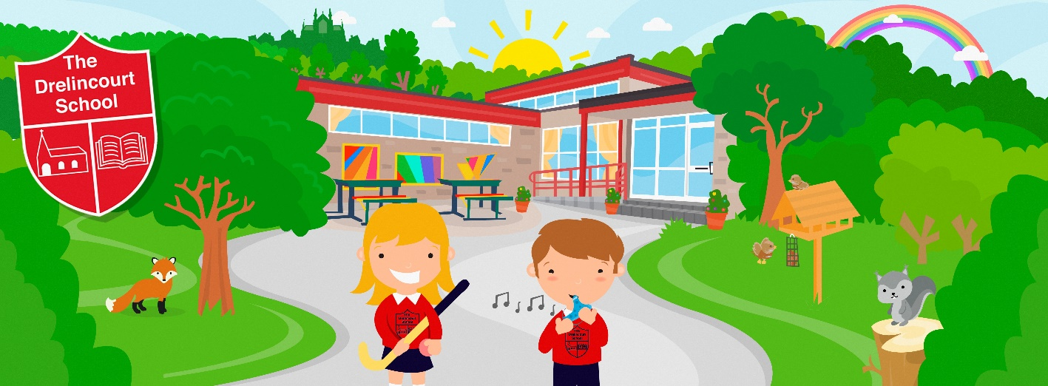

NEWSLETTER
October 2023

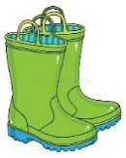
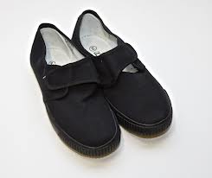
All children need PE shoes to take part in indoor PE. We have a lovely new floor in school and PE shoes must be used. We will be having lots of outdoor play and children need welly boots which will be kept in school. We are hoping to go on some Autumn walks so please make sure your child has a waterproof coat every day.

We are a nut-free school so could we please ask that NO nuts or products containing nuts are sent to school. Children need a small healthy snack – they do not have time to eat 3-4 items. Could we please ask for a reusable water bottle that they can open and close themselves?

Could I ask that all notes and permission slips are returned as soon as possible to school – preferably the next day. Where permission is required, children will not be able to take part in the activity without the returned note. We endeavour to upload copies of the relevant notes to the school website in case letters are ‘lost’.
Dinner money is paid on Monday mornings and costs £13 for the week.

Hockey will continue on Tuesday mornings during October. Please remember your child should wear trainers.

Tuesday 10th October is World Mental Health Day and we will have a focus on mindfulness and mental health. We will be using our new sensory play area and doing lots of exercise and wellbeing activities.

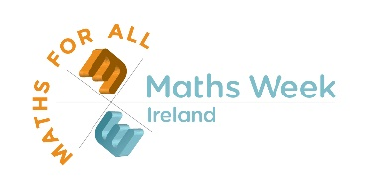
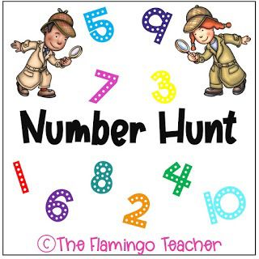
On Monday 16th October we start Maths Week Ireland for lots of interactive maths activities

On Wednesday 18th October we will be celebrating Pink Day with the children to raise money for Breast Cancer. If children have any pink clothes, they can wear these to school, and we will be making and eating pink buns! If families are able, children can bring a £2 donation for this very important charity.

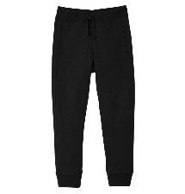
Swimming continues on Monday. Could I ask that ALL clothing is marked with names and make sure your child has a waterproof coat on Mondays as they will not be able to walk to the pool without one. Girls need a swimming hat and if they could have their hair plaited or tied back it makes it easier to put their swimming hats on and keeps the hair drier. Girls may also wear black trousers/joggers in the colder weather instead of tights and skirts.

Parent/Teacher meetings class will take place the week beginning Monday 23rd October. Thank you for your support in this.

*Children will go home at 1.30pm on Friday 27th October for the Half term holiday*
School will be closed
- Monday 30th October – Friday 3rd November for Half Term Holiday

