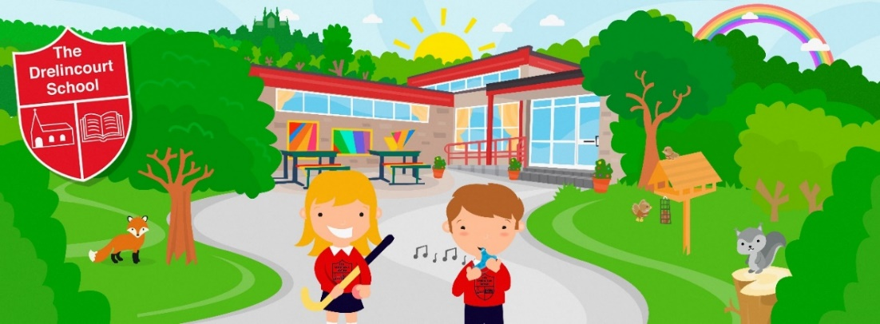

NEWSLETTER
JUNE 2023

School reports will be sent home on Monday 12th June.

Monday 12th June – Friday 17th June is Healthy Eating Week, and we will be learning about different kinds of healthy food.

We will be sending home family recipe meal kits on Fridays as part of the Brite Box Organisation and we are delighted that they are providing this free of charge to our families. We really hope you enjoy cooking with your child and creating family meals together on Fridays. This will hopefully continue next year.

On Tuesday 20th June we will be marking World Refugee Day and doing activities with the children to raise awareness of the plight of refugees around the world. In particular we will be thinking about Ukraine. We have a range of story books and resources to use to help the children understand this important topic.

IMPORTANT
*School will close at 12 noon on Friday 16th June*
*School will finish at 12 noon on Thursday 29th June*

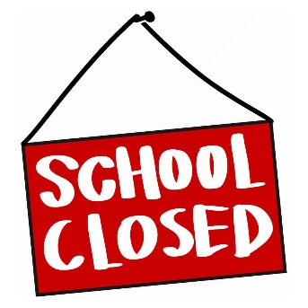
School finishes for the summer at 12 noon on Friday 30th June.

Back to school arrangements
Wednesday 30th August – 8.40am -12 noon
Thursday 31st August – 8.40am-12 noon
Friday 1st September – 8.40am – 12 noon
From Monday 4th September onwards – 8.40am – 1.30pm
From Monday 18th September onwards – 8.40am – 2.30pm

How we stay in touch with you

Make sure you are connected to your child’s Seesaw family account and you can send and receive direct messages with any queries you have.
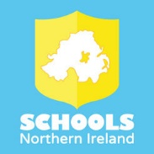
Please download the app (free) to enable you to receive messages. The content can also be translated into different languages which we hope will be helpful.

We also have a text message system to your mobile phone number.

We also put information, news and updates on the school website. Please check regularly.
www.drelincourt.org.uk
We also use email, and you can email us at
info@thedrelincourt.armagh.ni.sch.uk

We also have a new school Facebook page, please like, follow and share
@TheDrelincourt

We have a school Twitter account
@TheDrelincourt

