The Drelincourt School
Covid-19 Parent Declaration

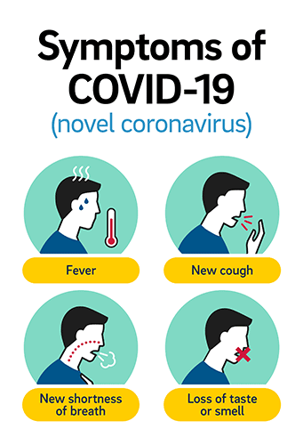
I understand that the symptoms of Covid-19 are
- High temperature
- New and/or continuous cough
- Loss of taste and smell

I will not send my child to school if they have any of these symptoms.

I will inform school if my child has any of these symptoms or if anyone in the house has these symptoms.

Child’s name________________________________________
Parent signature _____________________________________

