Appendix 1

Buddy’s Online Safety Rules for Children

Internet Safety Rules

1. Always ask a grown-up for help if you see anything strange or unusual.
2. Don’t download or install anything without asking a grown-up first.
3. Remember, not all games and videos are for children.
4. Don’t talk to strangers online and don’t tell them where you live.
5. If you are ever unsure what to do, remember Buddy’s song, and always ask for help.

Buddy’s ‘Use Your Tablet Safely’ Song
(Sung to the tune of Frère Jacques)
Ask your grown-up,
Ask your grown-up,
Ask for help!
Ask for help!
Use your tablet safely,
Use your tablet safely,
Woof, woof, woof!
Woof, woof, woof!

Under 5’s checklist for parents

START setting some boundaries now – it’s never too early to do things like set limits for the amount of time they can spend on the computer
KEEP devices like your mobile out of reach and make sure you have passwords/PINs set up on them for the times you might lend them to your child... or for when they simply get hold of them themselves!
CHECK the age ratings and descriptions on apps, games, online TV and films before downloading them and allowing your son or daughter to play with or watch them
EXPLAIN your technology rules to grandparents, babysitters and the parents of your child’s friends so that they also stick to them when they’re looking after your child
REMEMBER that public Wi-Fi (e.g. in cafés) might not have Parental Controls on it – so, if you hand over your iPad to your child while you’re having a coffee, they might be able to access more than you bargained for
SET the homepage on your family computer or tablet to an appropriate website like CBeebies
Reference: http://www.vodafone.com/content/parents/get started.htm

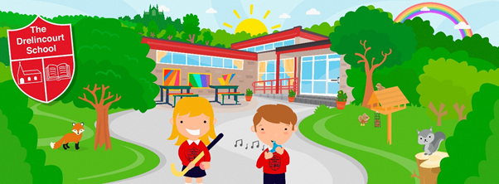

The Drelincourt School
Online Safety - Summary Guide for Parents
Online safety encompasses internet technologies and electronic communications such as computers, iPads, mobile phones and other portable digital devices.
Online safety relies on effective practice at various levels:
- Responsible use of ICT by all staff and pupils
- Thorough implementation of the online safety policy.
- The provision of a safe and secure internet network with monitored filtering system
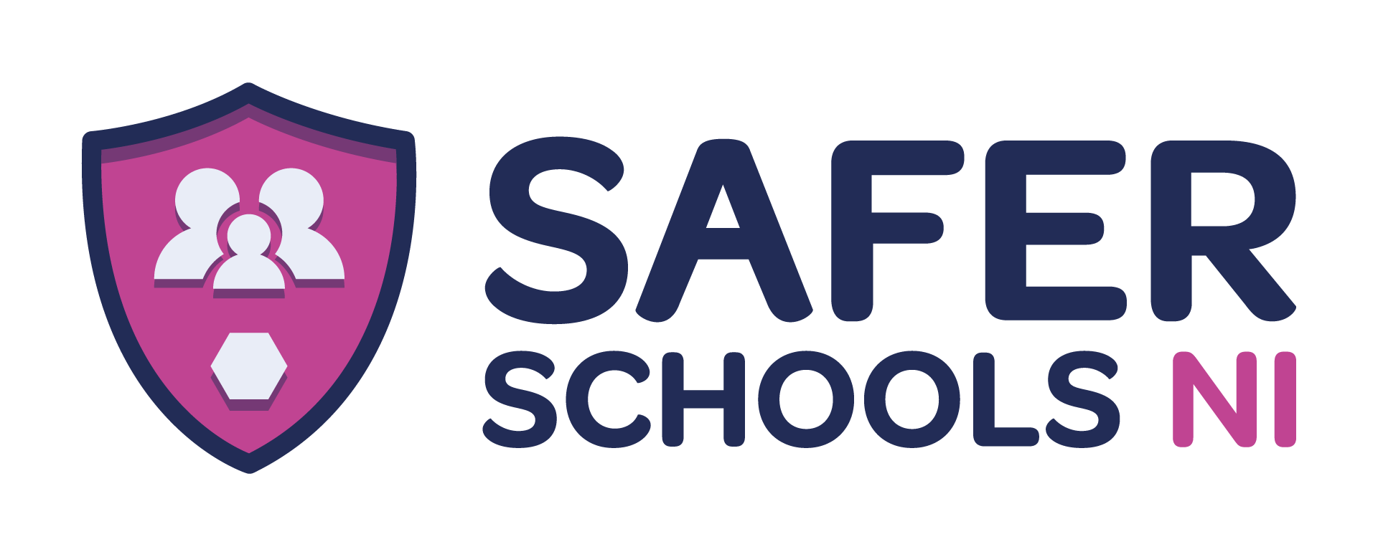
We have a significant role to play in keeping children safe and that includes online. Whether we provide internet access or not, young children will usually have access to the internet at home and we need to ensure their safety and well-being wherever they are.
The Drelincourt School adopts a pro-active approach to online safety through the use of age appropriate materials to reinforce and teach consistent messages. We also make use of the Safe School’s NI App and we strongly encourage parents to download and make use of this App to keep up to date with online safety issues.
Discuss with your child the Internet Use Agreement and sign and return to school.

Copy of full policy available on the school website www.drelincourt.org.uk

