Appendix 6
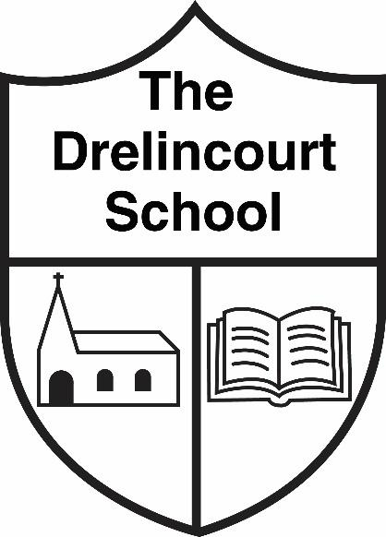
The Drelincourt School - Drugs Policy - Parent’s Guide

AIM OF POLICY
The programme is a preventative one and is pupil centred, delivered through active learning. The aims of the programme give children the opportunity to:

- discuss how medicines help us to stay healthy by visiting the doctor/hospital.
- understand simple rules associated with medicines
- highlight the importance of adults giving medicine to children.
- be aware of harmful substances that may be found at home including bleach which may be identified as dangerous to drink.
- make informed choices regarding taking medicines or harmful substances

PROCEDURE
A suspected drug related incident is described as:
- Suspect drugs or paraphernalia found on the school premises
- A pupil suspected of being in possession of drugs
- A pupil found to be in possession of drugs
- A pupil suspected of being under the influence of drugs
When an incident occurs the member of staff involved should:
- Make the situation safe.
- Send for support.
- Administer first aid if necessary.
- If a drug is found, gloves should be used and it should be secured in a safe place until dealt with by the police.
- Report the incident.

Full policy available on the school website - www.drelincourt.org.uk

