The Drelincourt School

First Aid and Administration of Medication Policy

December: 2021
Date of Review: December 2023

INTRODUCTION

The Drelincourt School provides a safe and happy environment where every pupil can develop to the very best of their ability. We want each child to remember this school as a happy place where they were nurtured, valued and inspired:
‘A little school for little people’
We have a responsibility for the safeguarding and child protection of the children in our care and we will carry out this duty by providing a caring, supportive and safe environment, where each child is valued for his or her unique talents and abilities, and in which all our young children can learn and develop to their full potential and be treated with dignity and respect.
First Aid and Administration of Medication Policy
At The Drelincourt School, we take the welfare of our children and staff seriously and make every effort to prevent accidents. In the event of an accident occurring, or a person presenting as unwell, we aim to act quickly and provide first aid where necessary.
First Aid Provision
The Principal will ensure through the risk assessment process that adequate provisions are made to administer first aid for any injuries sustained by employees or pupils whilst in school. Mrs Ritchie (Classroom Assistant/Building’s Supervisor), has been appropriately trained and supported to carry out her role in accordance with the duties in the Health and Safety (First Aid) Regulations (Northern Ireland) 1982. Mrs Ritchie’s name, as first aider, is prominently displayed in the school.

The First Aid box/bags are located on the right hand shelf in the P.E. store.
First Aid training has been completed by:-
- Mrs Sonia Ritchie ( December 2020) - valid for 3 years
Procedures
Any injury which involves e.g.: Blood, bumps, swelling, bruising, suspect broken bones, nose bleed, choking, nausea, dizziness, fainting or unconsciousness should be dealt with immediately according to the following procedure:
1. Stay calm and take mental note of time, place and circumstances and deal with injured child or adult.
2. Calm the injured child or adult.
3. Decide on treatment, if necessary.
4. Administer First Aid, if necessary.
5. The only medication administered will be to clean wounds (water and cotton wool and sterile wipe).
6. If injury needs medical attention inform Mrs Ritchie or the Mrs Trew (Principal) immediately.
7. Child’s parent/guardian must be contacted.
8. If injury needs professional medical attention call 999 on school mobile.
9. If a child has to go to hospital a member of staff will accompany.
10. If a child has to go home the teacher should enquire about his/her well-being within a reasonable time.
11. Immediately after the crisis is over, write an account of incident together with details of treatment on an accident form to be photocopied and put into accident file. Date, time and sign each entry and give to the Principal together with statements of any witnesses.

Parents
Parents must inform school if there are any specific medical issues for their child, e.g. asthma, allergies, allergy to plasters, other ongoing medical conditions. Parents complete a medical history form when their child enrolls in the school. These are reviewed annually.
Policy for the administration of medication in school
Up to date anaphylaxis training will be carried out by all staff as and when required. Mrs Ritchie’s First Aid training has covered general information on epilepsy - further training will be carried out as and when required.
“IT IS IMPORTANT TO NOTE there may be occasions where school staff may be asked to administer medication, but they cannot be directed to do so. The administration of medication to children remains the responsibility of the parent or those with parental responsibility. Medication should only be taken to school when absolutely essential and with the agreement of the Principal and class teacher. Parents are encouraged to request, where possible, that medication be prescribed in dose frequencies which enable it to be taken outside school hours. Schools should be alerted to the particular risks for young persons in taking Aspirin and Ibuprofen and should not routinely administer these unless under clear medical guidance.” (DE guidance – Supporting children with medical needs, 2008)
The Board of Governors and staff at The Drelicourt School wish to ensure that pupils with medication needs receive appropriate care and support at school. The Principal will accept responsibility in principle for members of the school staff giving or supervising pupils taking prescribed medication during the school day, where those members of staff have volunteered to do so, however it is expected that parents of a child who has an infectious condition or is unwell, should not send the child to school. If a child is, or becomes unwell during the school day, staff will contact a parent, or if a parent is not available, another person nominated by the parent. They may be asked to collect the child from school.
Where it is necessary to keep medications in school, e.g. asthma inhalers or adrenaline injections,
Parents are responsible for:
- Making sure that their child is well enough to attend school;
- Making the school aware that their child requires medication;
- Reaching agreement with the Principal and class teacher on the school’s role in helping with their child’s medication;
- Providing the Principal and class teacher with written instructions and making a written agreement. Details of the dose and when the medication is to be administered, are essential. Prescribed medication will not be accepted in school without complete written and signed instructions from the parent;
- Ensuring any changes in medication or condition are notified promptly;
- Providing sufficient medication and ensuring it is correctly labelled;
- Ensuring that medication is replaced before expiry date is reached;
- Disposing of their child’s unused medication;
- Each item of medication must be delivered to the Principal or class teacher, in normal circumstances by the parent, in a secure and labelled container as originally dispensed.

This should state :-
- Pupil’s name.
- Name of medication.
- Dosage.
- Frequency of administration.
- Date of dispensing.
- Storage requirements (if important).
- Expiry date.
In school:-
- Medication will be kept in a secure place, out of the reach of pupils.
- The school will keep records of administration of any medication, which they will have available for parents.
- Where medication is needed intermittently, e.g. occasional use of inhaler, parents will be informed of this at the end of the day, or earlier if necessary.
- If children refuse to take medicines, staff will not force them to do so, and will inform the parents of the refusal, as a matter of urgency, on the same day.
- If a refusal to take medicines results in an emergency, the school’s emergency procedures will be followed.
- The school will not make changes to dosages on parental instruction.
- Staff will not give a non-prescribed medicine (e.g. Calpol) to a child.
- Staff who volunteer to assist in the administration of medication will receive appropriate training/guidance through arrangements made with the School Health Service or other appropriate health professional.
Pupils with a long term condition requiring regular medication, e.g. anaphylaxis, epilepsy
Depending on the severity of their condition these children may require a Medical Plan, which may indicate additional staff training. In these instances, school staff should
- Never give medication without appropriate training from health professionals.
- For children with significant medication needs an individual programme of training will be devised.
- All training should be reviewed at least annually and be child-specific.
- Training should be arranged in conjunction with the Health and Social Services Trusts, Community Pediatricians, School Nurse/Community
- Children’s Nurse or other health professionals.
- A health-care professional should confirm that any training has given staff sufficient understanding, confidence and proficiency in medical procedures and communicate this to the employer.
- Training should be for named staff member(s) in the specific procedure(s) for each named child or children. The training programme undertaken must be planned and recorded in detail for the named staff member/members.
- The training in specific procedures should include: information on the individual child’s Medical Plan; the requirement to maintain the child’s confidentiality; instruction on the procedure required by demonstration, followed by supervised practice where appropriate, and supported by a written protocol. This protocol should include the actions necessary for the trained person to implement and will become part of the pupil’s Medication Plan; and where appropriate, child protection or intimate care issues must be addressed.
- Ideally, the staff should be trained before the child starts attending school, but, otherwise, parents must be aware that they will need to continue being responsible for the procedures until staff are trained.
- If no trained person is available on a particular day, the parents should be advised of this and take responsibility for the medical needs of the child during the school day.
- The school will make every effort to continue the administration of medication to a pupil whilst on trips away from the school premises, even if additional arrangements might be required. However, there may be occasions when it is not possible to include a pupil on a school trip, e.g. if appropriate supervision and safety cannot be guaranteed.
- All staff will be made aware of the procedures to be followed in the event of an emergency.
Emergency First Aid
“Any individual can take action to preserve life provided that the action is carried out with the best of intentions and is performed in good faith. Teachers and other staff are expected to use their best endeavors at all times in emergencies. In general, the consequences of taking no action are likely to be more serious than those of trying to assist in an emergency.” (DE guidance – Supporting children with medical needs, 2008)
As part of our risk management in school, all staff will be informed of any children with known medical conditions and/or medical plans.
Some examples of main medical conditions are:
- Acute asthmatic attack requiring more inhalers/attention than usual routine doses
- Diabetic hypoglycemic attack requiring Glucose (glucose tablets or hypostop)
- Anaphylactic reaction requiring Adrenaline (e.g. EpiPen® or Anapen®).
- Prolonged epileptic seizures.
For a child with a Medical Plan, the potential for an emergency to arise will be reflected in the plan, which will incorporate a plan of action, should an emergency occur. Staff will be expected to follow the advice given in that Medical Plan. Temporary staff, who may be in
attendance and may not have the level of awareness and understanding of permanent staff, are expected to act within their own competencies and experience and obtain appropriate help.
Where a pupil experiences an emergency event with no relevant previous history, staff are expected to take all reasonable steps within their own competencies and experiences to assist the pupil and obtain the appropriate help.
Emergency Procedures
In the event of an emergency, the class teacher should stay with the child and direct a member of staff to call 999.
Parents must be alerted immediately.
A pupil taken to hospital by ambulance should be accompanied by a member of staff who should remain until the pupil’s parent arrives. Where possible, the member of staff should have details of any health care needs and medication of the pupil and/or a copy of the Medical Plan. Health professionals are responsible for any decisions on medical treatment when parents are not available.
Staff should never take children to hospital in their own car; it is safer to call an ambulance.
Individual Care or Medical Plans should include instructions as to how to manage a child in an emergency, and identify who has the responsibility in an emergency.
The incident should be fully recorded.
In all emergency situations a teacher or other member of school staff will be expected to act as a responsible adult or parent in the best interests of the child in recognition of their duty of care.
If in doubt, phone for the emergency services.

This policy will be reviewed and monitored in line with the school’s policy review schedule.

COVID-19 Guidance
What happens if a child or member of staff is unwell?
- If a child is unwell, he/she should not attend school, no matter the cause of the illness. If a child is ill due to vomiting or diarrhoea, the school will follow the Public Health Guidelines stating the child can return to school after being free of symptoms for 48 hours to avoid the spread of infection.
- Staff or children who have any symptoms associated with COVID-19 must not attend school, as advised by the Public Health Agency.
The main symptoms of coronavirus are:
- a high temperature – this means you feel hot to touch on your chest or back (you do not need to measure your temperature).
- a new, continuous cough – this means coughing a lot for more than an hour, or 3 or more coughing episodes in 24 hours (if you usually have a cough, it may be worse than usual).
- a loss or change to your sense of smell or taste – this means you've noticed you cannot smell or taste anything, or things smell or taste different to normal.

- If children or members of staff are identified as close contacts, they will be contacted by the PHA and will need to follow the guidance given to them by the PHA before returning to school.
- If children or members of staff tests positive for COVID-19, they must not return to school. They must follow the guidance given to them by the PHA before returning.
What happens if a child displays symptoms during school?

COVID-19 GUIDANCE (In line with current Covid-19 risk assessments)
- If a child becomes unwell with coronavirus symptoms, he/she and any household members also attending The Drelincourt School will be sent home and advised to follow the PHA guidance for households with possible coronavirus infection.
- A child awaiting collection will be moved to an area where they can be supervised by one member of staff.
- The child/children cannot return to school until the Public Health Agency advice under the Test, Trace and Protect programme has been followed.
- PPE will be worn by staff caring for the child while they await collection.
- The member of staff does not need to go home unless she develops symptoms herself. She should wash her hands thoroughly for 20 seconds after any contact with someone who has developed symptoms.
- The affected area will be cleaned, followed by disinfection after someone with symptoms has left, to reduce the risk of passing the infection on to other people.
- Shared spare clothing will be removed and parents to send in clothes for their own child to be kept in school.
- Staff will check each child’s temperature each morning before they enter the classroom.

The COVID-19 Guidance will be reviewed regularly and in line with new PHA Guidance.
The First Aid and Administration of Medication Policy will be reviewed and monitored in line with the school’s policy review schedule.

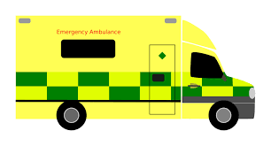
Emergency Call Form

Request for an Ambulance to: The Drelincourt School
Dial 999, ask for an ambulance and be ready with the following information.
- School telephone number 028 37523714

- School name, address and postcode
The Drelincourt School
23A Ballinahone Avenue
Armagh
BT60 1EE

3. Give your name
4. Give brief description of pupil’s symptoms
5. Inform Ambulance Control of the best entrance and state that the crew will be met and taken to the patient

(If possible an additional member of staff will wait outside gate for ambulance)

Appendix 1

Healthcare Plan for a Pupil with Medical Needs
Name _____________________
Date of Birth _______________

Photograph

Condition _______________________________________
________________________________________________
________________________________________________
Class ___________________________________________
Name of School ___________________________________

Contact Information
Family Contact 1
Name
___________________________________________________________________________ Phone No. (work) __________________________ (home) __________________________
Relationship
___________________________________________________________________________ Family Contact 2
Name
___________________________________________________________________________ Phone No. (work) __________________________ (home) _________________________
Relationship
___________________________________________________________________________

Clinic/Hospital Contact
Name
___________________________________________________________________________
Phone No.
___________________________________________________________________________
G.P.
___________________________________________________________________________ Name _____________________________Phone No. ________________________________ Describe condition and give details of pupil’s individual symptoms:
___________________________________________________________________________ ___________________________________________________________________________ ___________________________________________________________________________ Daily care requirements, (e.g. before sport/at lunchtime):
______________________________________________________________________________________________________________________________________________________________________________________________________________________________ Describe what constitutes an emergency for the pupil, and the action to take if this occurs:
____________________________________________________________________________________________________________________________________________________ __________________________________________________________________________
Follow up care:
___________________________________________________________________________ ___________________________________________________________________________ ___________________________________________________________________________
Who is responsible in an emergency: (State if different on off-site activities) ___________________________________________________________________________ ___________________________________________________________________________ ___________________________________________________________________________
Form copied to:
___________________________________________________________________________

Appendix 2
Request by Parent for School to administer medication
The school will not give your child medicine unless you complete and sign this form, and the Principal has agreed that school staff can administer the medication.
Pupil Details
Surname:
___________________________________________________________________________
Forename(s)
___________________________________________________________________________
Address:
___________________________________________________________________________ ___________________________________________________________________________ ___________________________________________________________________________ M/F:_________
Date of Birth: ________________________
Class/Form: _________________________
Condition or illness:
___________________________________________________________________________ ___________________________________________________________________________ ___________________________________________________________________________ Medication
Name/ Type of medication (as described on the container)
___________________________________________________________________________ ___________________________________________________________________________ For how long will your child take this medication:
___________________________________________________________________________ ___________________________________________________________________________ Date dispensed: ___________________________
Full direction for use:
____________________________________________________________________________________________________________________________________________________

Dosage and method:
___________________________________________________________________________ ___________________________________________________________________________ Timing: _______________________
Special precautions:
___________________________________________________________________________ ___________________________________________________________________________ Side effects:
___________________________________________________________________________ ___________________________________________________________________________
Self-administration:
___________________________________________________________________________ Procedures to take in an Emergency:
___________________________________________________________________________ ___________________________________________________________________________ Contact Details
Name:
___________________________________________________________________________
Daytime Telephone No:
_________________________________________________________________________
Relationship to Pupil:
___________________________________________________________________________
Address:
___________________________________________________________________________
I understand that I must deliver the medicine personally to (agreed member of staff) and accept that this is a service which the school is not obliged to undertake.
Date: ______________________Signature(s): _____________________________________
Relationship to pupil:
___________________________________________________________________________
Appendix 3

The Drelincourt School - Permission to administer medication

I agree that ___________________ will receive ________________every day at _____________________.
____________________ will be given/ supervised whilst he/she takes their medication by __________________.
This arrangement will continue until _______________ or until instructed by parents.
Date: __________________________________
Signed: ________________________________ (The Principal)

Appendix 4
The Drelincourt School
First Aid and Administration of Medication - Parent’s Guide
PROCEDURES FOR FIRST AID AND ADMINISTRATION OF MEDICATION

At The Drelincourt School we make every effort to provide a safe environment for the children in our care. However, from time to time, accidents do occur and we aim to act quickly and provide first aid where necessary.

First Aider: Mrs S Ritchie

- Minor accident eg: a fall in the playground, the wound will be cleaned with water and sterile wipes and a plaster applied (with parental permission). Parent will be informed at hometime and a ‘Mr Bump’ note will be sent home with the child.
- Bump to the head - a cold compress will be applied and the parent will be contacted to come and take the child home for observation.
- Emergency /serious accident - staff will call 999 for an ambulance and the parent will be contacted immediately.

Medical conditions

- Medical History Form must be completed, outlining any specific medical conditions that the child may have eg: Asthma, allergies, epilepsy
- Child becomes unwell during the school day - parent will be contacted to take the child home.
- Infectious condition or sickness - child should not attend school. If a child is vomiting or has diarrhoea, the school will follow the Public Health Guidelines stating that they must be free of symptoms for at least 48 hours.
- Administration of medication throughout the day - parent must seek written permission and consent from the Principal.

COVID-19 Guidance

- If a child is unwell, he/she should not attend school
- Parent should continue to monitor their child at home for the main symptoms:
- a high temperature
- a new, continuous cough
- a loss or change to sense of smell or taste
- If a child tests positive for COVID-19, PHA guidance must be followed before returning to school.
- Staff will check child’s temperature each morning before they enter the school.

Full policy available on the school website - www.drelincourt.org.uk
Appendix 5

Dear parent,

You have received an overview of our First Aid Policy. Please sign and return the permission slip below. Please do not hesitate to contact the school if you would like to discuss this matter further.

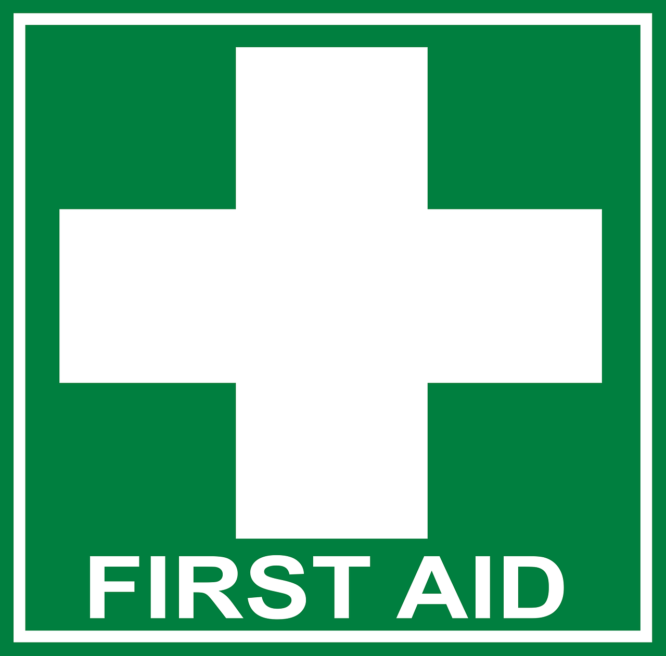
I have read the First Aid Policy and allow The Drelincourt staff to attend to my child | Yes/No
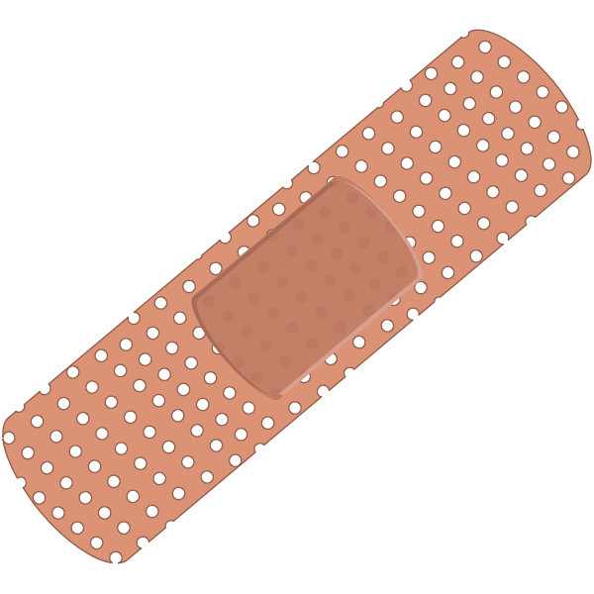  I allow The Drelincourt staff to administer plasters to my child | Yes/No
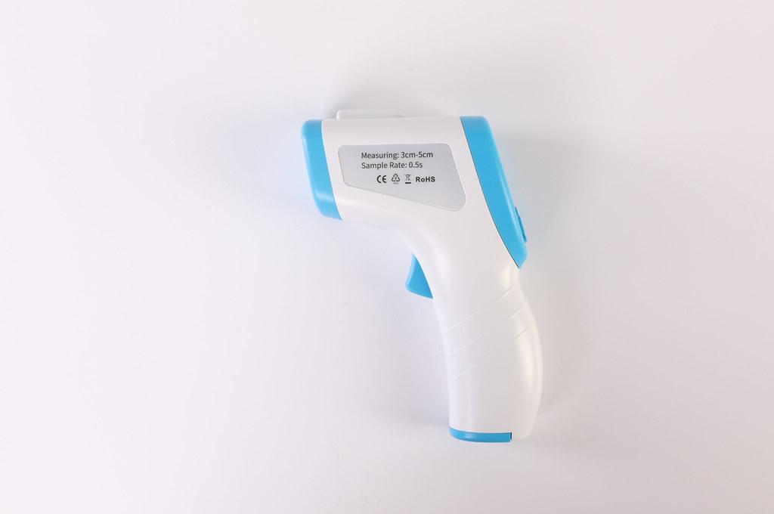  I allow my child’s temperature to be taken each morning and if he/she becomes unwell | Yes/No

Name of child:
Parent signature:
Date:

Appendix 6
Record of Medication Administered

Date | Pupil’s Name | Time | Name of Medication | Dose Given | Any Reactions | Staff Signature | Print Name

f
o

e
r
u
t
a
n
g
i
S
s
n
o
i
t
c
a
e
R

y
n
A
n
e
v
i
G

e
s
o
D
n
o
i
t
a
c
i
d
e
M

f
o

e
m
a
N

e
m
i
T

